**HOW TO USR COOKWARE**

Rinse thoroughly, then dry with a soft towel. For nonstick stainless steel cookware, condition prior to initial use with 1 tsp (5 ml) of vegetable oil. Simply wipe the oil over the interior gently using a soft cloth. Repeat the conditioning process every 2 to 3 months, or if food begins to stick to the pan.

**How Do I Prepare Stainless Steel Cookware?**

Wash your new stainless steel cookware in warm, soapy water with ¼ cup of vinegar to remove any traces of manufacturing oils. Rinse thoroughly, then dry with a soft towel.

For nonstick stainless steel cookware, condition prior to initial use with 1 tsp (5 ml) of vegetable oil. Simply wipe the oil over the interior gently using a soft cloth. Repeat the conditioning process every 2 to 3 months, or if food begins to stick to the pan.

Pro tip: Avoid using nonstick sprays on nonstick pans. Over time, they cause an invisible buildup that impairs the nonstick release system, thereby actually causing food to stick to the nonstick pan.

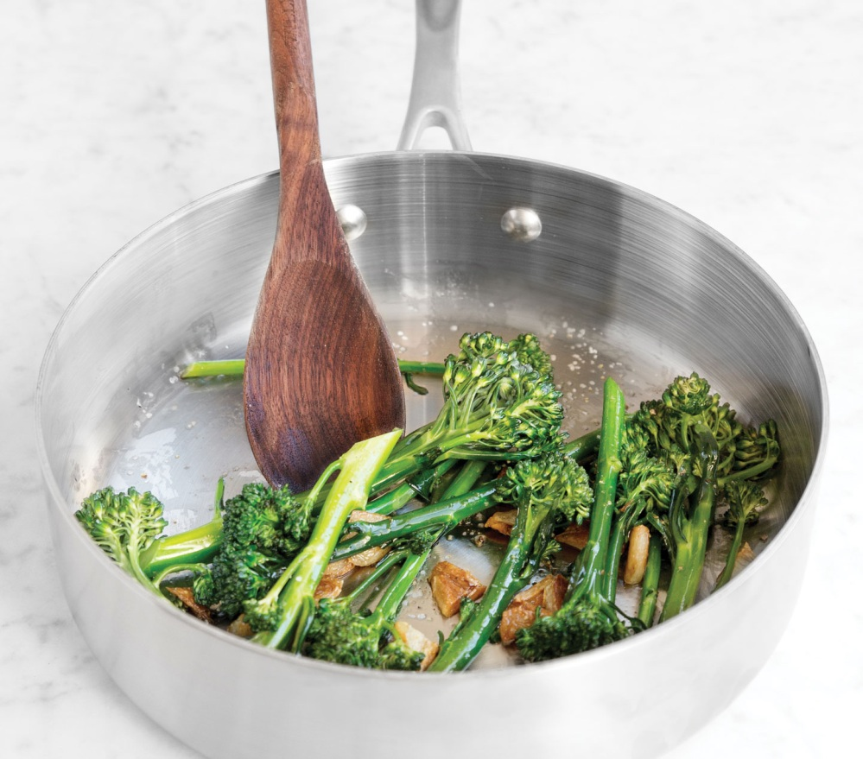

**How Do I Cook with Stainless Steel Cookware?**

For nonstick stainless steel cookware, you should try to solely use low to medium heat. The center layer of our [tri-ply construction](https://americankitchencookware.com/the-tri-ply-stainless-steel-difference) is aluminum, which conducts heat extremely well. Scorching food, discoloring the pan, or damaging nonstick coating can be avoided by starting your recipes at a lower temperature. The stainless steel layers surrounding the tri-ply will hold heat consistently at your desired level. When using our stainless steel cookware, be sure to preheat the pans completely on low to medium heat before adding your food. To check the temperature, add a few water droplets to the surface. Once they slip easily along the pan without bubbling or evaporating, you’re ready to cook. While it is acceptable to cook with oil, you may not need it in our cookware. Meat or poultry will initially stick, but will loosen as their juices are released, enabling you to turn and cook the other side. Adjust the heat as needed, and cook until done.

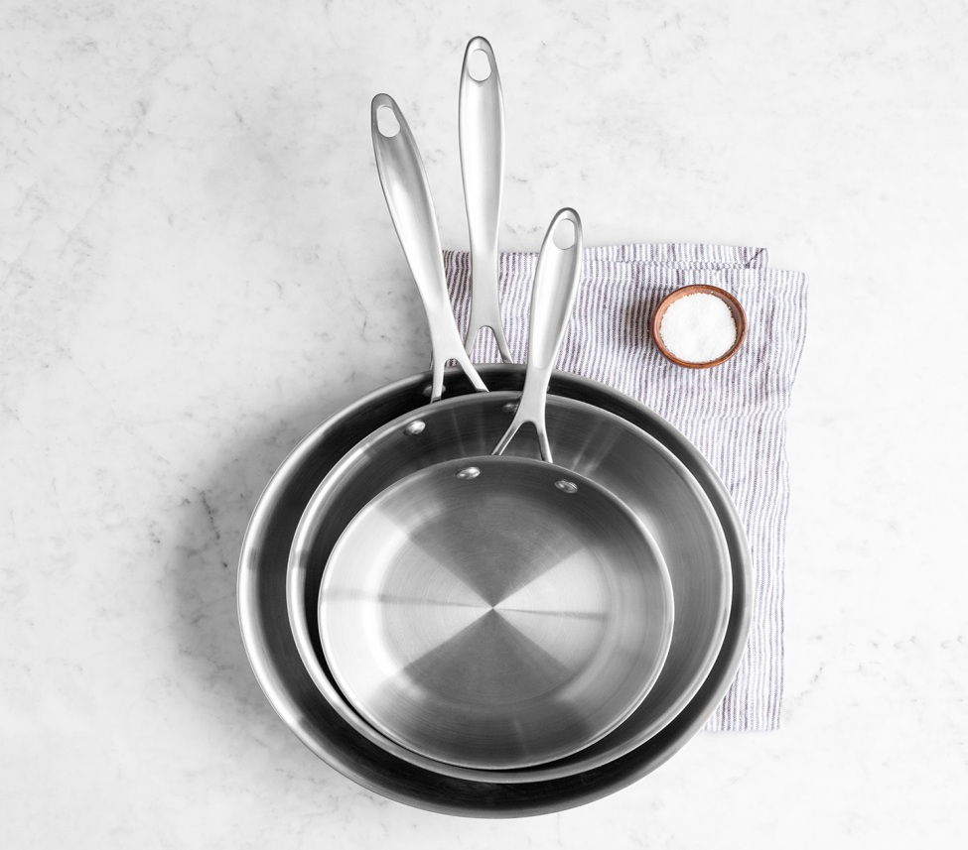

**How Do I Clean Stainless Steel Cookware?**

• Allow cookware to cool to room temperature before cleaning. Sudden changes in temperature may cause metal to warp, resulting in an uneven base. Avoid putting cold water or frozen food in a hot pan or plunging a hot pan into cold water.

• Rinse pan with water then wash in soapy water to remove stains or stuck-on food.

• For stubborn stains or discoloration cause by excessive heat, make a paste of water and a non-abrasive, non-chlorine stainless steel cleanser such as Barkeeper’s Friend, then rub paste in a circular motion using a damp paper towel. Wash paste away with warm, soapy water, rinse thoroughly and dry.

• Pro tip: All of our stainless steel cookware is dishwasher safe, however, we recommend hand washing to preserve the beautiful finish.

**How Do I Care for Stainless Steel Cookware Glass Covers & Lids?**

Helpful Tips for Maintaining Glass Covers:

• Do not place glass covers on a burner, in a toaster oven, under a broiler, or in the microwave oven. The heat will weaken the cover.

• Be careful not to strike the glass cover when cooking, storing, cleaning or serving.

• Do not use covers that are chipped, cracked, or severely scratched. Immediately replace damaged [lids](https://americankitchencookware.com/lids-specialty).

• Do not attempt to repair covers that are chipped or broken, and never reverse the glass covers when storing as the knobs may damage the nonstick interior.

